**Lab 18: Android Internal Storage using Kotlin**

# **Introduction**

Internal storage is the storage of the private data on the device memory. By default these files are private and are accessed by only your application and get deleted , when user delete your application.

# **Write into File (FileOutputStream)**

# **Read from File (FileInputStream)**

**Let’s get Started:**

**Step 1: Create a New Project in Android Studio as shown below**

**Step 2: Select Empty Activity as shown below**

**Step 3: Provide a Project Name as shown below**

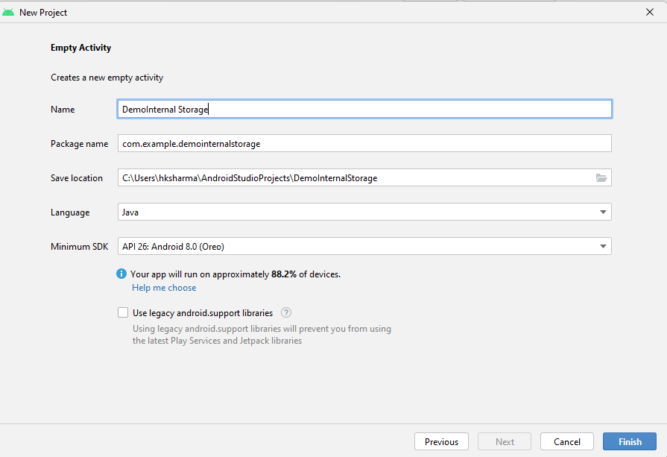

**Step 4: Update MainActivity.kt as per the code given below**

**package** com.example.demointernakotlin  
**import** android.content.Context  
*//import android.support.v7.app.AppCompatActivity***import** android.os.Bundle  
**import** android.view.View  
**import** android.widget.Button  
**import** android.widget.EditText  
**import** android.widget.Toast  
**import** androidx.appcompat.app.AppCompatActivity  
**import** java.io.*  
  
  
**class** MainActivity : AppCompatActivity() {  
  
 **override fun** onCreate(savedInstanceState: Bundle?) {  
 **super**.onCreate(savedInstanceState)  
 setContentView(R.layout.*activity_main*)  
  
 **val** fileName = findViewById<EditText>(R.id.*editFile*)  
 **val** fileData = findViewById<EditText>(R.id.*editData*)  
  
 **val** btnSave = findViewById<Button>(R.id.*btnSave*)  
 **val** btnView = findViewById<Button>(R.id.*btnView*)  
  
 btnSave.setOnClickListener(View.OnClickListener **{  
 val** file:String = fileName.*text*.toString()  
 **val** data:String = fileData.*text*.toString()  
 **val** fileOutputStream:FileOutputStream  
 **try** {  
 fileOutputStream = openFileOutput(file, Context.*MODE_PRIVATE*)  
 fileOutputStream.write(data.*toByteArray*())  
 } **catch** (e: FileNotFoundException){  
 e.printStackTrace()  
 }**catch** (e: NumberFormatException){  
 e.printStackTrace()  
 }**catch** (e: IOException){  
 e.printStackTrace()  
 }**catch** (e: Exception){  
 e.printStackTrace()  
 }  
 Toast.makeText(*applicationContext*,**"data save"**,Toast.*LENGTH_LONG*).show()  
 fileName.*text*.clear()  
 fileData.*text*.clear()  
 **}**)  
  
 btnView.setOnClickListener(View.OnClickListener **{  
 val** filename = fileName.*text*.toString()  
 **if**(filename.toString()!=**null** && filename.toString().*trim*()!=**""**){  
 **var** fileInputStream: FileInputStream? = **null** fileInputStream = openFileInput(filename)  
 **var** inputStreamReader: InputStreamReader = InputStreamReader(fileInputStream)  
 **val** bufferedReader: BufferedReader = BufferedReader(inputStreamReader)  
 **val** stringBuilder: StringBuilder = StringBuilder()  
 **var** text: String? = **null  
 while** (**{** text = bufferedReader.readLine(); text **}**() != **null**) {  
 stringBuilder.append(text)  
 }  
 *//Displaying data on EditText* fileData.setText(stringBuilder.toString()).toString()  
 }**else**{  
 Toast.makeText(*applicationContext*,**"file name cannot be blank"**,Toast.*LENGTH_LONG*).show()  
 }  
 **}**)  
  
 }  
}

**Step 5: Update activity_main.xml for Relative Layout as per the code given below**

*<?***xml version="1.0" encoding="utf-8"***?>*<**RelativeLayout xmlns:android="http://schemas.android.com/apk/res/android"  
 xmlns:app="http://schemas.android.com/apk/res-auto"  
 xmlns:tools="http://schemas.android.com/tools"  
 android:layout_width="match_parent"  
 android:layout_height="match_parent"  
 tools:context="example.javatpoint.com.kotlininternalstoragereadwrite.MainActivity"**>  
  
 <**TextView  
 android:id="@+id/textView"  
 android:layout_width="wrap_content"  
 android:layout_height="wrap_content"  
 android:layout_alignParentLeft="true"  
 android:layout_alignParentStart="true"  
 android:layout_alignParentTop="true"  
 android:layout_marginLeft="31dp"  
 android:layout_marginStart="31dp"  
 android:layout_marginTop="117dp"  
 android:text="File Name"  
 android:textAppearance="@style/Base.TextAppearance.AppCompat.Medium"**/>  
  
 <**EditText  
 android:id="@+id/editFile"  
 android:layout_width="wrap_content"  
 android:layout_height="wrap_content"  
 android:layout_alignBaseline="@+id/textView"  
 android:layout_alignBottom="@+id/textView"  
 android:layout_alignLeft="@+id/btnSave"  
 android:layout_alignStart="@+id/btnSave"  
 android:layout_marginLeft="31dp"  
 android:layout_marginStart="31dp"  
 android:ems="10"  
 android:paddingLeft="10dp"  
 android:inputType="textPersonName"  
 android:hint="file name"** />  
  
 <**TextView  
 android:id="@+id/textView2"  
 android:layout_width="wrap_content"  
 android:layout_height="wrap_content"  
 android:layout_alignEnd="@+id/textView"  
 android:layout_alignRight="@+id/textView"  
 android:layout_below="@+id/textView"  
 android:layout_marginTop="67dp"  
 android:text="File Data"  
 android:textAppearance="@style/Base.TextAppearance.AppCompat.Medium"**/>  
  
 <**EditText  
 android:id="@+id/editData"  
 android:layout_width="wrap_content"  
 android:layout_height="wrap_content"  
 android:layout_alignBaseline="@+id/textView2"  
 android:layout_alignBottom="@+id/textView2"  
 android:layout_alignLeft="@+id/editFile"  
 android:layout_alignStart="@+id/editFile"  
 android:ems="10"  
 android:lines="5"  
 android:hint="data"** />  
  
 <**Button  
 android:id="@+id/btnSave"  
 android:layout_width="wrap_content"  
 android:layout_height="wrap_content"  
 android:layout_alignLeft="@+id/textView2"  
 android:layout_alignParentBottom="true"  
 android:layout_alignStart="@+id/textView2"  
 android:layout_marginBottom="53dp"  
 android:layout_marginLeft="49dp"  
 android:layout_marginStart="49dp"  
 android:text="Save"** />  
  
 <**Button  
 android:id="@+id/btnView"  
 android:layout_width="wrap_content"  
 android:layout_height="wrap_content"  
 android:layout_alignEnd="@+id/editData"  
 android:layout_alignRight="@+id/editData"  
 android:layout_alignTop="@+id/btnSave"  
 android:layout_marginEnd="33dp"  
 android:layout_marginRight="33dp"  
 android:text="View"** />  
</**RelativeLayout**>

**Step 6: Check Output on Android Emulator and it should look like as given below**

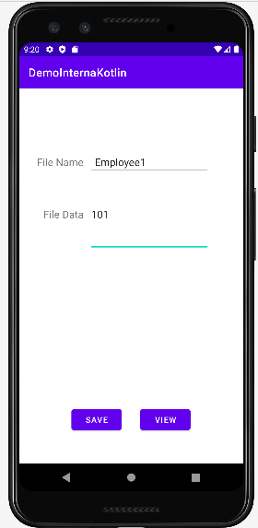

**Voila!!** We have successfully completed this lab.